Seat No. : _______________

AS-102

May-2016
B.C.A., Sem.-II
CC-111 : Mathematical Foundation of Computer Science

Time : 3 Hours] [Max. Marks : 70

1. (A) (1) Verify the properties, existence of identity and existence of inverse (for each of the elements of a set) for the following binary operations on a set of positive integers. 8
(i) a * b = a + b – 1
(ii) a * b = $\frac{ab}{2}$
(2) Prove that every cyclic group is abelian.
OR
(A) (1) Show that a set G = {(a, b, c) / a, b, c ∈ R} is a group with respect to the operation addition defined as follows : 8
For any α = (a1, b1, c1), β = (a2, b2, c2) ∈ G, α + β = (a1 + a2, b1 + b2, c1 + c2)
(2) Prove that identity element in a Group is unique.
(B) (1) Show that a set G = {2n / n ∈ Z } under multiplication is a cyclic group. 6
(2) Show that if G is an abelian Group, then for any a, b ∈ G, (ab)2 = a2 b2.
OR
(1) Find the order of each element of a multiplicative group G = {a, a2, a3, a4, a5, a6 = e}. 6
(2) State Lagrange’s Theorem. How many subgroups are there for the group of order 11 ?

2. (A) (1) Let a set X = {1, 2, 3, 4}. The relation matrix M(R) on a set X is given below : 8
M(R) =
Answer the following questions.
(i) Give Domain and Range of the relation.
(ii) Is this relation reflexive ?
(iii) Is this relation irreflexive ?
(iv) Is this relation Symmetric ?
(2) Define an equivalence relation and equivalence classes. Is the following relation an equivalence on the set X = {1, 2, 3}.
R = {(1, 1), (1, 2), (1, 3), (2, 2), (3, 1)}
OR
(1) Give relation matrix and relation graph of a relation on a set X = {1, 2, 3, 4} defined by R = {⟨x, y⟩ / x, y ∈ X, x < y}. 8
(2) Show that a set ⟨P(A), ⊆) , where A = {1, 2, 3}, with the relation inclusion is a Poset.

(B) (1) Draw the Hass diagram of the Poset ⟨S210, D⟩. 6
(2) Find minimal and maximal elements for the Poset ⟨P, D⟩, where P = {2, 3, 6, 12, 18, 36}, and D means “divides”. Also find greatest lower bound of a subset (6, 12, 18} of P.
OR
(1) Define partition of a set. Determine whether or not the following sets are partition of the set Z of integers with justification. 6
pl = {{x ∈ Z / x < 5}, {x ∈ Z / x > 5}}
p2 = {{2n / n ∈ Z}, {2n + l / n ∈ Z}}
(2) Define Chain. Give an example of a Poset which is not a chain.

3. (A) (1) Show that the operations of meet and join on a lattice are commutative and idempotent. 8
(2) Define a Sub-Boolean Algebra. Find any three sub-Boolean Algebra of the Boolean Algebra ⟨S66, D⟩ where Sm is a set of divisors of m and D is a partial ordering relation divides.
OR
(1) Define Boolean Algebra. Prove that in a Boolean Algebra, a < b ⇔ b' < a' 8
(2) Define Complete lattice. Is a lattices ⟨S6, D⟩, complete ? Justify your answer. (Sm is a set of divisors of m and D is a partial ordering relation divides)
(B) (1) If exists, find complement of each element of a lattice ⟨P(A), ∩, ∪⟩, where A = {1, 2, 3}. 6
(2) In a Boolean Algebra prove that, a = b ⇒ ab' + a'b = 0
OR
(1) By giving an example show that any subset of a lattice need not be a sublattice. 6
(2) Let ⟨L, *, ⊕⟩ be a chain with L = {a, b, c}. If a < b < c, show that L is a distributive lattice.

4. (A) (1) Are the following graphs Isomorphic ? Justify your answer. 8
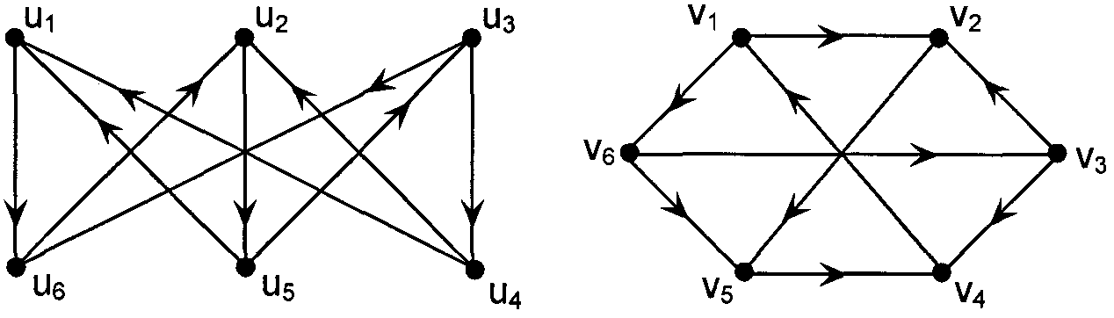
Figure – 1
(2) Give other representation of the Tree expressed by,
(V0(V1(V2)( V3(V4)))( V5(V6)( V7(V8)(V9)))(V10(V11(V12))))
OR
(A) (1) Are the simple graphs with the following adjacency matrices isomorphic ? Draw the graph of each adjacency matrices. 8
M(G1) = and M(G2) =
(2) Define binary tree. Give the binary tree representation for the following tree representation.
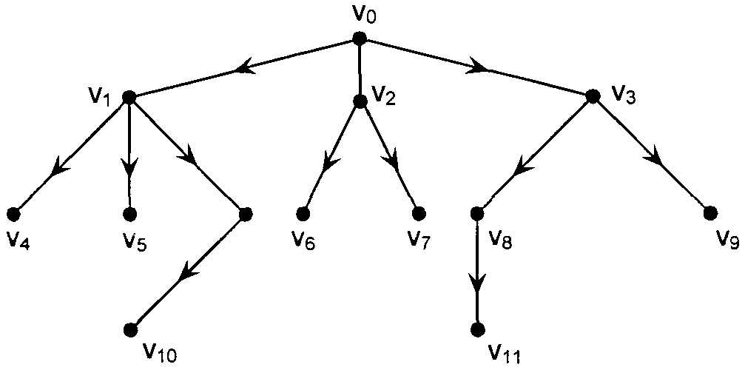
Figure – 2
(B) (1) Find the reachable set of vertices v1, v5 and v10 form the following graph. 6
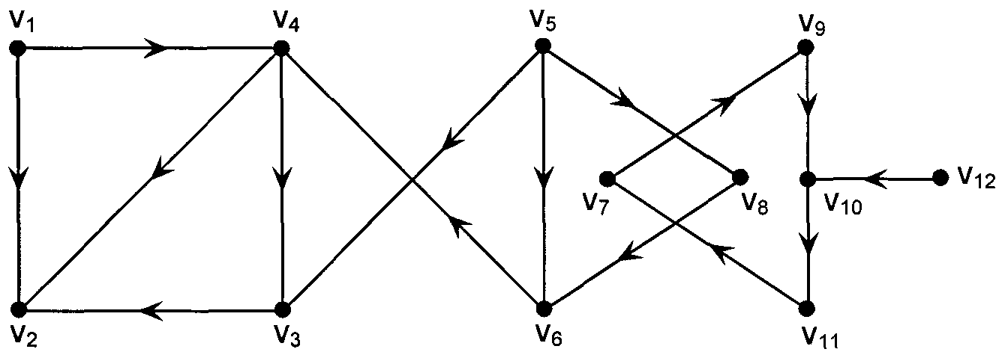
Figure – 3
(2) Define node base. Find the node base of the graph given in figure-3 above.
OR
(1) From the given graph G answer the following questions.
(i) Give a geodesic path from the vertex ‘v5’ to the vertex ‘v1’.
(ii) Find the distance between two vertices v1 and v5.
(iii) Give the reachable set of a set {v1, v2, v4}.
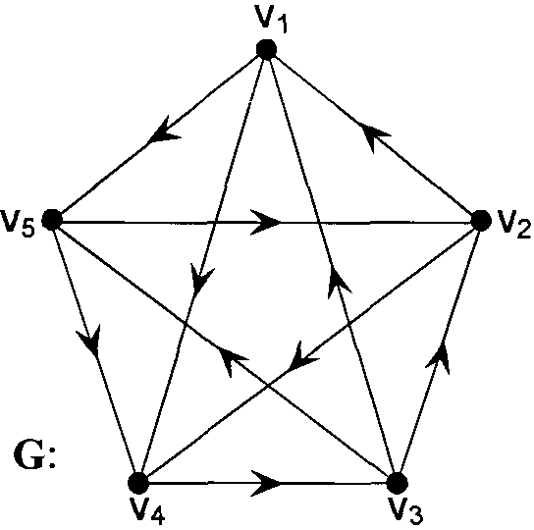
Figure - 4
(2) Give an adjacency matrix for the graph G given in the figure – 4 above. Also draw the subgraph H with V(H) = V(G) – {v1}.
5. Do as Directed. 14
(1) A cyclic group has only one generator. (True / False)
(2) The set N of all positive integers is a group with respect to operation _____.
(a) Addition (b) Multiplication
(c) a * b = a + b – 2 (d) None of these
(3) In the additive group of integers the order of every element is _____.
(a) Zero (b) n
(c) infinite (d) None of these
(4) Every subgroup of an abelian group is abelian. (True / False)
(5) There are _____ distinct permutations on a set of n elements.
(a) n (b) n + l
(c) n – 1 (d) None of these
(6) A covering of a set is always a partition of that set. (True / False)
(7) A relation is symmetric if its matrix is _____.
(a) Symmetric (b) Anti-symmetric
(c) Square (d) None of these
(8) If the Domain and Range of a relation are same then relation is _____.
(a) Reflexive (b) Symmetric
(c) Equivalence (d) None of these
(9) A Poset P is a lattice if for any a, b ∈ P, _____.
(a) a * b ∈ P (b) a * b = 0
(c) (a * b)' = a' ⊕ b' (d) None of these
(10) Every Boolean Algebra is a lattice. (True / False)
(11) ⟨S6, D⟩ is a sublattice of a lattice ⟨S12, D⟩.
(a) ⟨S12, D⟩ (b) ⟨S30, D⟩
(c) ⟨S45, D⟩ (d) None of these
(12) Every subset of a lattice is a sublattice. (True / False)
(13) Let a bounded lattice ⟨L, * , ⊕, 0, 1⟩. An element b ∈ L is called a complement of an element a ∈ L if _____.
(a) a * b = a and a ⊕ b = b (b) a * b = b * a and a ⊕ b = b ⊕ a
(c) a * b = 0 and a ⊕ b = 1 (d) None of these
(14) In a Boolean Algebra ⟨B, *, ⊕, ‘, 0, 1⟩, for any a, b ∈ B, (a * b)' = _____.
(a) a' (b) 0
(c) l (d) None of these
_____________

